Heart Disease Prediction Using Machine Learning
Prepared By : SOWMIYA A
Role : Machine Learning Intern

Introduction
Heart disease is one of the leading causes of death worldwide. Early detection of heart-related problems can help doctors provide timely treatment and reduce the risk of severe complications. However, manual diagnosis based on medical tests can sometimes be time-consuming and may depend on human interpretation.
To overcome this challenge, machine learning techniques can be used to analyze patient medical data and predict the likelihood of heart disease. Machine learning models can learn patterns from historical patient records such as age, blood pressure, cholesterol level, chest pain type, and other clinical parameters.
In this project, we use a dataset containing patient health information and build machine learning models to predict whether a person is likely to have heart disease or not. The goal is to assist in early detection and support medical decision-making using data-driven techniques.
The project includes data preprocessing, exploratory data analysis (EDA), model building using algorithms like Logistic Regression, Decision Tree, and Random Forest, and evaluation of model performance to identify the best model for prediction.
This system demonstrates how artificial intelligence can be applied in the healthcare domain to improve diagnosis accuracy and support healthcare professionals.

Import Libraries
import pandas as pd
import numpy as np
import matplotlib.pyplot as plt
import seaborn as sns

from sklearn.model_selection import train_test_split
from sklearn.preprocessing import StandardScaler
from sklearn.linear_model import LogisticRegression
from sklearn.tree import DecisionTreeClassifier
from sklearn.ensemble import RandomForestClassifier
from sklearn.metrics import accuracy_score, confusion_matrix

Dataset View
df = pd.read_csv("/content/heart.csv")
print(df.head())
print(df.info())
print("Shape:", df.shape)
print(df["target"].value_counts())
OUTPUT:

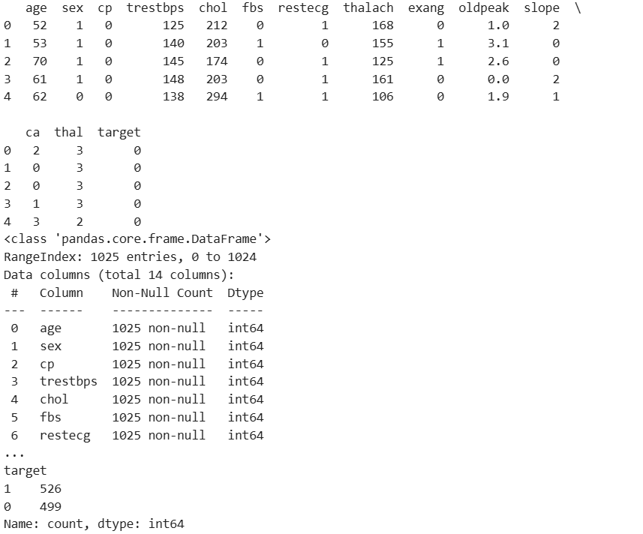
# Age vs Disease
plt.figure(figsize=(8,5))
sns.histplot(data=df, x="age", hue="target", bins=20)
plt.title("Age vs Heart Disease")
plt.show()
OUTPUT:

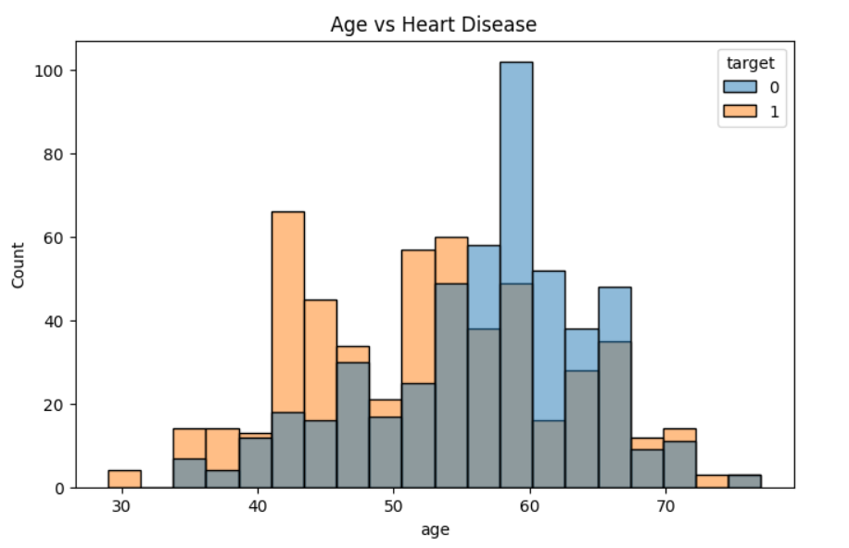

# Chest Pain vs Disease
plt.figure(figsize=(8,5))
sns.countplot(data=df, x="cp", hue="target")
plt.title("Chest Pain Type vs Disease")
plt.show()
OUTPUT:

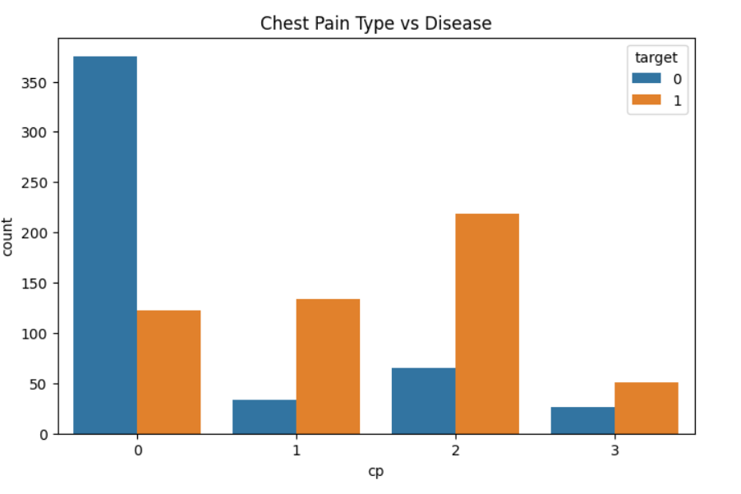
# Gender vs Disease
plt.figure(figsize=(6,4))
sns.countplot(data=df, x="sex", hue="target")
plt.title("Gender vs Disease")
plt.show()
OUTPUT:

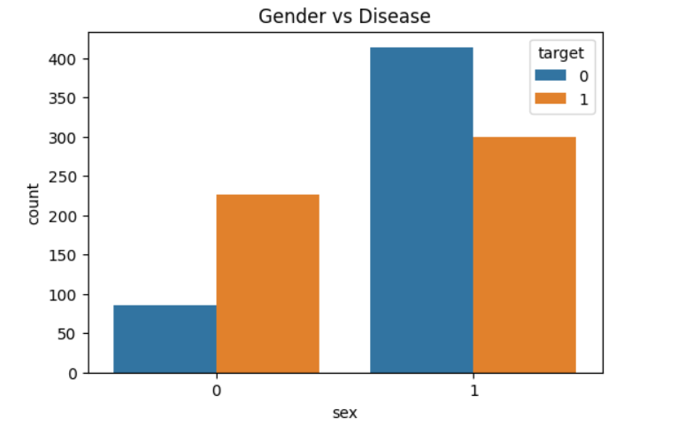
# Cholesterol vs Disease
plt.figure(figsize=(6,4))
sns.boxplot(data=df, x="target", y="chol")
plt.title("Cholesterol vs Disease")
plt.show()
OUTPUT:
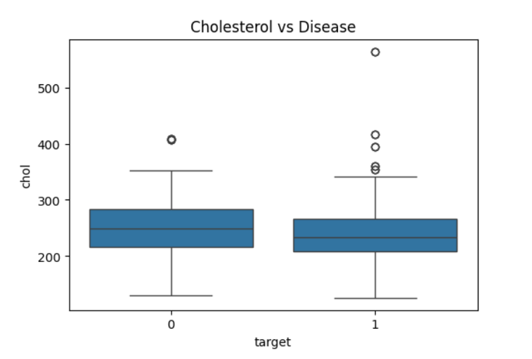
df["age_group"] = pd.cut(df["age"],
bins=[20,30,40,50,60,70,80],
labels=["20-30","30-40","40-50","50-60","60-70","70-80"])

plt.figure(figsize=(8,5))
sns.countplot(data=df, x="age_group", hue="target")
plt.title("Age Group vs Heart Disease")
plt.show()
OUTPUT:
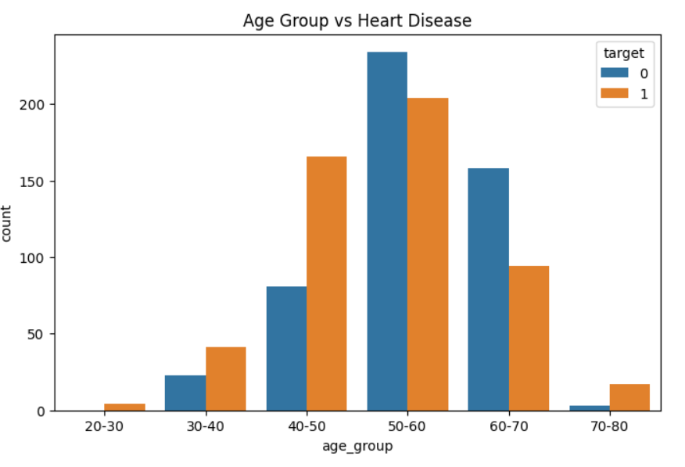
X = df.drop(["target", "age_group"], axis=1)
y = df["target"]

X_train, X_test, y_train, y_test = train_test_split(
X, y, test_size=0.2, random_state=42
)

scaler = StandardScaler()
X_train = scaler.fit_transform(X_train)
X_test = scaler.transform(X_test)

lr = LogisticRegression()
dt = DecisionTreeClassifier()
rf = RandomForestClassifier()

lr.fit(X_train, y_train)
dt.fit(X_train, y_train)
rf.fit(X_train, y_train)

y_pred_lr = lr.predict(X_test)
y_pred_dt = dt.predict(X_test)
y_pred_rf = rf.predict(X_test)

print("\nMODEL ACCURACY")
print("Logistic Regression:", accuracy_score(y_test, y_pred_lr))
print("Decision Tree:", accuracy_score(y_test, y_pred_dt))
print("Random Forest:", accuracy_score(y_test, y_pred_rf))
OUTPUT:
MODEL ACCURACY
- Logistic Regression: 0.7951219512195122
- Decision Tree: 0.9853658536585366
- RandomForest:0.9853658536585366
cm = confusion_matrix(y_test, y_pred_rf)

sns.heatmap(cm, annot=True, fmt="d", cmap="Blues")
plt.title("Random Forest Confusion Matrix")
plt.show()
OUTPUT:
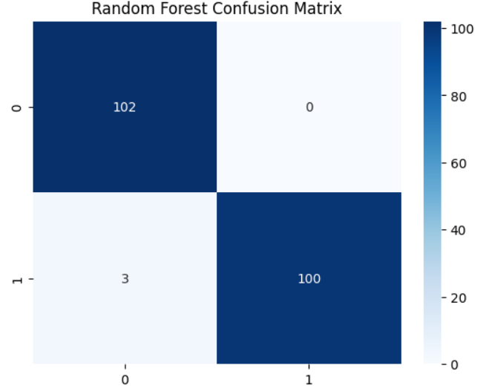
importances = rf.feature_importances_

plt.figure(figsize=(10,5))
sns.barplot(x=importances, y=X.columns)
plt.title("Feature Importance")
plt.show()
OUTPUT:
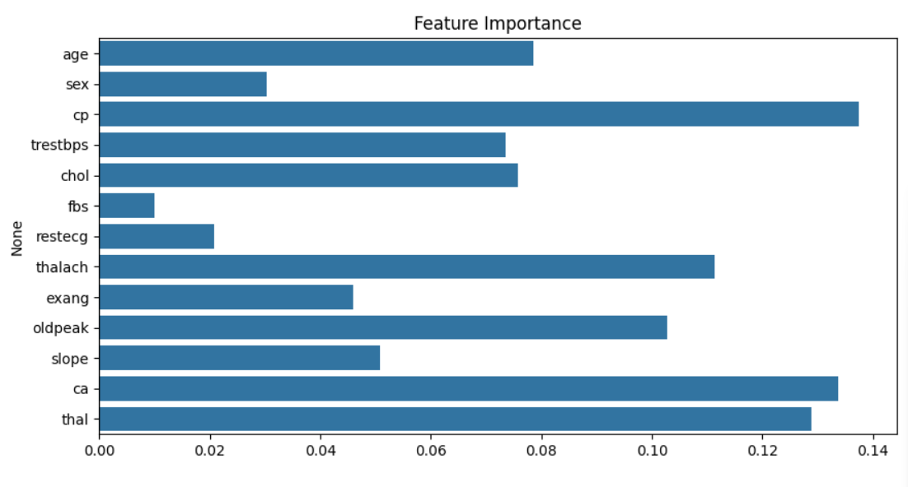
print("\nMean Values by Target:")
print(df.select_dtypes(include=np.number).groupby(df["target"]).mean())
OUTPUT:

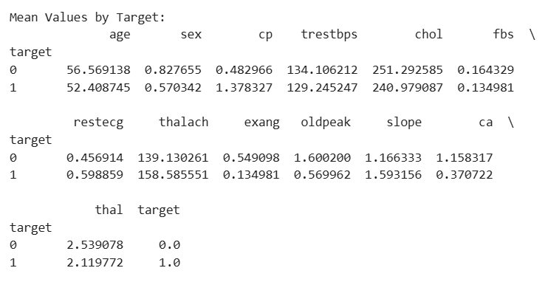
sample_patient = [[
63, 1, 3, 145, 233, 1, 0, 150, 0, 2.3, 0, 0, 1
]]

sample_patient = scaler.transform(sample_patient)

prediction = rf.predict(sample_patient)
prob = rf.predict_proba(sample_patient)

print("\nPREDICTION:")
if prediction[0] == 1:
print("⚠️ Heart Disease Risk Detected")
else:
print("✅ No Heart Disease")

print("Probability:")
print("No Disease:", prob[0][0])
print("Disease:", prob[0][1])

OUTPUT:
PREDICTION:
⚠️ Heart Disease Risk Detected
Probability:
No Disease: 0.0
Disease: 1.0
Conclusion
In this project, machine learning models were used to predict heart disease using patient medical data. The dataset was analyzed, and different algorithms like Logistic Regression, Decision Tree, and Random Forest were applied.
Among all models, Random Forest gave the best accuracy. The system can successfully predict whether a person has heart disease or not based on input features.
This project shows how machine learning can help in early detection of heart disease and support medical decision-making.

